Act 2
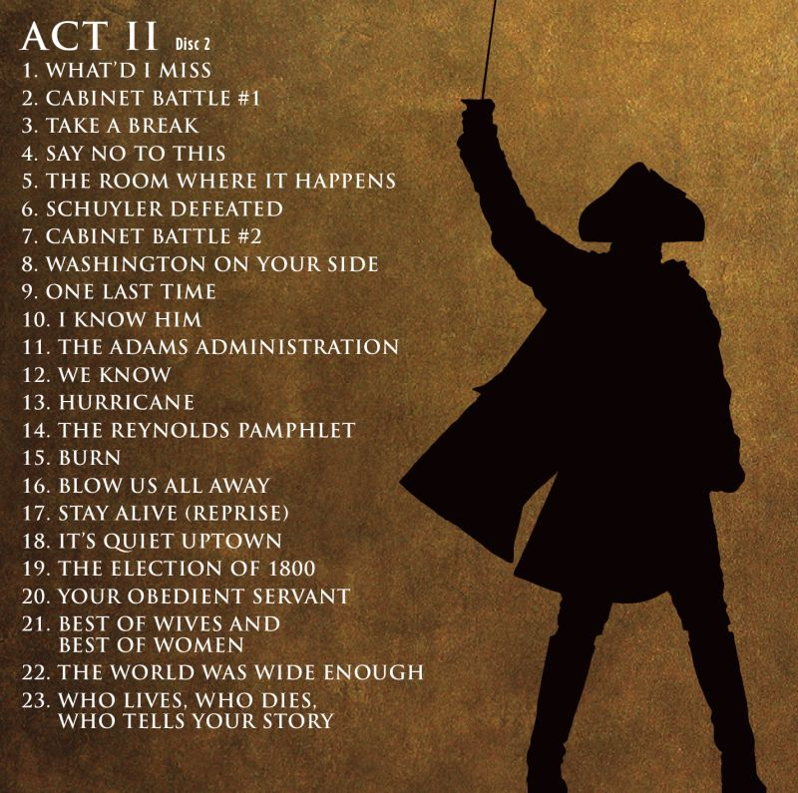
Act 2 – Hamilton Musical
In 1789, Thomas _____________ returns to _____________ from ____________, where he spent most of the revolution as an ambassador. Washington asks him to be ______________ of State. Jefferson accepts and heads to __________ _________, where he is met by James ________________ who asks him to help stop Hamilton’s _________________ plan, which Madison believes gives the government too much _______________ . Jefferson and Hamilton then engage in a _______________ over the merits of Hamilton’s financial plan during a cabinet meeting. ________________ orders a break as the debate gets heated, pulls __________________ aside, and tells him to figure out a __________________ to win over _______________ or else he’ll lose his position as the Secretary of __________________.
Hamilton begins working at ___________________, and _________________ reminds him that it’s _______________’s ninth birthday. She tells him that Phillip has something to show him. He performs a short ______________, which amazes ___________________. Eliza then asks Hamilton if he wants to accompany her on ________________ upstate at her _________________’s home. Hamilton _________________, saying that he has to work on his plan for ________________. In England, ________________ fawns over the last letter Hamilton sent her, in which he wrote “My Dearest, Angelica…;” she is excited by the fact that by placing the _______________ where he did, Hamilton has referred to her as his “_____________.” She also advises him to convince ________________ of his plan in order for Congress to accept it. When she arrives, though she is _________________ to see Eliza, she is ___________________that Hamilton won’t be joining them and tries to convince him otherwise. In the end, the Schuyler sisters end up leaving _________________ him.
While Eliza is on vacation, Hamilton is visited by Maria _________________, who claims her husband is ________________ her. Hamilton offers her some _________________ and walks her _______________. When they arrive at her house, she invites him inside and _________________ him. They begin to have an _______________. Maria’s husband James Reynolds __________________ Hamilton into paying him money. Hamilton is furious with _________________. However, he pays Reynolds the money he requested, and continues the _________________.
Hamilton talks with Burr, tells him that he’ll be yielding Burr’s old advice to “talk __________, smile _____________” to get his plan approved. Hamilton then has to leave to discuss his plan with ______________ and ______________ over a private dinner, and resulting in the _______________ of 1790 giving _______________ to Hamilton’s financial plan in exchange for moving the United States capital from New York to ________________ (eventually becoming ____________________). Burr comments on how no one besides the men who were in the meeting know how decisions were made. Burr is __________________ of Hamilton’s sway in the government and wishes he had similar ________________.
At the Hamilton home, Phillip shows his mother a paper that says that her father, _____________ Schuyler, has lost his seat in the Senate to ________________. Eliza and Phillip express concern over how ________________ will react to the news. Elsewhere, Hamilton accuses Burr of switching ___________________ solely to run against his father-in-law. Burr says he was simply seizing the __________________, but Hamilton doesn’t believe him, driving a __________________ between the two friends.
In another cabinet meeting, Jefferson and Hamilton argue over whether or not the United States should assist ______________ in their revolution. Jefferson urges people to remember what France has done for the _______________ Revolution, but Hamilton argues that Jefferson doesn’t understand what a ______________ is really like, since he spent the American Revolution in ________________, and that they should remain _________________. __________________agrees with Hamilton, and the Congress decides to remain ___________________ on the situation. After the meeting, Burr, Jefferson, and Madison bemoan how nice it must be for Hamilton to always have ________________’s support, and they seek a way to _______________ Hamilton’s image. Soon after, Washington tells Hamilton that Jefferson has _________________ from his position in government. Hamilton promises to ruin Jefferson, but then Washington clarifies that Jefferson is running for ________________, and that Washington himself is ______________ __________________. Hamilton is shocked, but Washington convinces him that it is the right thing to do, and they write a farewell address.
In England, King _______________ III receives news about George Washington’s step down from leadership, and was unaware that someone could _________________ from power. He is then told about the new president, ____________ ______________, and refers to him as “that __________________ guy that spoke to me.” George then exits merrily, ready for the United States to fall under Adams’ leadership.
Adams and Hamilton have a huge altercation and effectively destroy each other’s reputation and the _______________Party. Madison points out to Jefferson, who is now Vice President, and Burr that without ______________ and without his position, Hamilton now has no authority to oppose them. Jefferson says that this isn’t enough, because Hamilton with a pen is still a ______________. He suggests they tell Hamilton about the ________________ they think they’ve found out about. The three approach Hamilton, and accuse him of ___________________ government money and committing ______________. In reality, however, they found the transactions from his affair with ______________ _______________. Hamilton, knowing that the truth is the only way out, tells them about his ______________ and begs them not to tell anyone. Hamilton, still worried that they will tell, thinks about how writing openly and honestly has saved him in the past.
Hamilton publishes the ____________ that James and Maria ___________ wrote him, and writes about them in the ____________ pamphlet. Jefferson, Madison, and Burr ____________. Angelica, upon hearing the news, travels from England to comfort ______________. At night when she is alone, _____________ rereads all of the letters ______________ had written her, trying to find any sort of signs to why he would ever do this. Eliza then takes herself out of the _______________ by __________________ all of the letters, destroying Hamilton’s chance at redemption and keeping the world from knowing how she reacted.
Years pass, and _________________ has just graduated from King’s College at the age of ________________. He is praised for having the same _________________ and good looks as his ________________. Phillip is upset to find out that a man named George Eacker has been saying ___________ _____________ about his ________________ and challenges him to a _______________. Hamilton orders Phillip to aim his gun to the ____________ instead of at _______________, and if Eacker is a man of ______________ he will follow suit. Phillip promises to do so. The duel countdown begins, and Phillip is aiming for the sky from the beginning. However, by the time they reach _______________, Eacker shoots Phillip. He is taken to a ______________, and Hamilton rushes to his side, but it is too ________________. Hamilton comforts __________________, who promises his father that he did everything he told him to. A horrified _______________ arrives, and stays with him until he ______________.
In the aftermath of Phillip’s death, the Hamilton family moves _______________. Hamilton and Eliza have become _________________, and Angelica, serving as a ________________, tells everyone to have _______________ for him, as they are coping with the “___________________.” During this time, Hamilton tries and succeeds in gaining Eliza’s _________________ .
The Presidential Election of 1800 ends up in a tie between _________________ and ________________. Burr comes across Hamilton and tells him that he’s doing everything he can to be President, and that he learned that from ________________. Hamilton is upset that Burr has once again _________________ his own ideals to try to win, instead of sticking to his own convictions. When Hamilton is bombarded by people asking for his opinion on whom to vote for, he shocks everyone by choosing _________________. He says that even though he has never ________________ with him, Jefferson has ______________, unlike _______________. Jefferson ends up _________________ by a landslide.
Over the next few months, Burr and Hamilton exchange a series of passive aggressive _______________ to each other. Burr implies that Hamilton backed Jefferson solely to ______________ him, and Hamilton says he was just telling the ________________. Burr, enraged, challenges Hamilton to a ______________, which Hamilton _______________ . Hamilton awakes early on the morning of the duel. Eliza asks him to come back to bed, but Hamilton says he has to leave.
The next morning, Burr and Hamilton travel to ______________ ______________ with their seconds and a doctor. Burr points out that Hamilton is wearing his _______________. He says there’s no reason for that unless Hamilton means to take _______________ aim. The men raise their guns to shoot, and just before a shot sounds, everything ______________ – people and music alike. Only ________________ remains, and he comments on how much he has thought about ______________, his relationships, and wonders about his _____________. He then aims his pistol at the _______________, just like _______________ did. Then time resumes, Burr ______________ Hamilton, and he falls. Hamilton ______________ soon after, with both ______________ and ______________ by his side. Burr laments on how even though he survived, he’s cursed to be the _________________ in history, remembered only as the man who ________________ Alexander Hamilton. He realizes that no one needed to die that day because the world was ______________ enough for both Hamilton and him in it.
Everyone congregates for the epilogue. Washington enters and poses the same advice about history he once gave to Hamilton, “you have no ______________ over who ____________ who ____________, who tells your _______________.” _______________ and ______________ laud ______________’s genius despite their ______________, while Angelica and Burr wonder how Hamilton will be _____________. Eliza then enters. She explains how she tells her husband’s ______________ over the next fifty years she lives. She tries to organize and make sense of Hamilton’s thousands of writings, interviews every soldier who fought with him, raises funds for the ___________________ monument, speaks out against _______________, and founds the first private _________________ in New York City. She still frets that she has not done ________________, and then says she can’t wait to see ________________ again. Hamilton then joins her and beckons her forward. She gazes with awe out into some blissful beyond as everyone asks who will tell her _______________, and the show ends as they ask the audience the same question.

